Rezone: A multi-objective optimisation tool for land use allocation in multiple-use environments.

Stanley Mastrantonis a, *, Michael D. Craig ab, Richard J. Hobbs a, Andrew H. Grigg c & Michael Rentona

a School of Biological Sciences, University of Western Australia, Stirling Highway, Crawley, WA 6009, Australia

b School of Environmental and Conservation Sciences, Murdoch University, Murdoch, WA 6150, Australia

c Alcoa Australia, Huntly Mine, PO Box 172, Pinjarra WA 6208, Australia

* Corresponding author: stanley.mastrantonis@ research.uwa.edu.au

*Keywords*: biodiversity offsets, land use allocation, machine learning, multi-objective optimisation, Pareto optimality, R, spatial conservation prioritisation.

ABSTRACT

Across the world, wildlife must coexist with humans in production landscapes. Strategies for biodiversity management in these types of modified landscapes include multi-objective optimization and spatial conservation prioritisation. These approaches seek to optimise land use allocation to improve ecosystem and biodiversity management while accounting for trade-offs between anthropogenic activities and conservation actions. Several software packages exist for spatial conservation prioritisation and optimisation, most of which assume ecological value from data such as species distributions, habitats or ecosystem services, and allocate land use based on these data inputs. In reality, the ecological value of landscapes for many species, especially for mobile species, is derived from the spatial configuration of the functional resources it depends on, and how these resources interact to support its life-history. Here, we have developed a novel approach for optimising landscape conservation based explicitly on the spatial interactions of resources for a species. This software includes multi-objective decision-making support tools that optimise outcomes for production and conservation, as well as a heuristic algorithm that informs management of optimal locations for establishing biodiversity offsets. We present a case study of this software’s functionality for a multiple-use mining landscape within a global biodiversity hotspot.

**1. Introduction**

Multi-objective optimisation, otherwise known as multi-criteria optimisation or Pareto optimisation, are commonly used techniques in environmental management scenarios, such as waste and water management, and have also been used for land use allocation (Kaim et al., 2018; Xevi and Khan, 2005; Xi et al., 2010). Decisions with respect to multi-objective optimisation can be aided by visualising trade-offs of Pareto optimality through the Pareto frontier, where the improvement of one objective function can only occur at the detriment of another objective function (Lotov and Miettinen, 2008). For example, the more land that is allocated for agriculture across a region, the less capacity that region has to support biodiversity. Agricultural production and biodiversity conservation are two important, yet contrasting, objectives that can occur in a complex landscape, and applying Pareto optimality to these land use scenarios can simplify the decision making process. Managers can make any decision across the Pareto frontier, knowing the trade-off between two conflicting objectives, and algorithms will tailor outcomes to this decision where both objective functions are optimised. Thus, these multi-objective optimisation and prioritisation techniques have proven to be effective strategies in scenarios where conflicting objective arise due to anthropogenic land use and conservation (Kaim et al., 2018). In recent decades, land use optimisation and spatial conservation prioritisation techniques have seen increasing implementation for conservation, resource management and regulation (Jones et al., 2016; Kennedy et al., 2008; Moilanen et al., 2020; Venegas‐Li et al., 2018). This is because, when managing regions for the protections of species and ecosystems, multi-objective optimisation can resolve conflicts effectively and benefit both conservation and socioeconomic outcomes (Huang et al., 2011; Kaim et al., 2018). Indeed, the potential for multi-objective optimisation to inform decisions make it an appealing choice for environmental management, but the implementation of these methods for land use allocation can be complex. Optimisation and prioritisation require spatial data representing biodiversity, ecosystem services, stakeholder interests and economic factors, as well as quantitative models that assess trade-offs and allocate land use optimally (Castrejón and Charles, 2020; Jumin et al., 2018). Importantly, biodiversity offsetting has also become an increasingly popular and important tool when planning for spatial conservation and prioritisation, and biodiversity offsets broaden the possibilities available to managers when faced with complex decisions (Bull et al., 2013; Moilanen et al., 2020).

For spatial conservation prioritisation and objective optimisation, several software packages and bespoke algorithms exist to evaluate, quantify and parse regions with spatially explicit boundaries which represent the various levels of control, restriction and management (Moilanen et al., 2005; Watts et al., 2009). More recently, these software have incorporated functions to evaluate offset scenarios into the multi-objective decision making process, and allocate land use with respect to the spatial configuration of biodiversity offsets (Moilanen et al., 2020). In general, these methods allocate land use and conservation priorities on the assumptions that spatial data inputs, such as species distributions, habitat classification, environmental gradients, ecosystem services, remotely sensed indices or dimensionally reduced data adequately represent essential biodiversity variables or ecosystem services (Jetz et al., 2019; Jumin et al., 2018; Shen et al., 2020; Studwell et al., 2017). However, the dynamic distributions and behaviours of species as well as the value of natural landscapes and features do not necessarily conform to probabilistic and correlative model outputs, principal components, classifications or simplified measurements. A model may predict high occurrence probability or habitat suitability for a species in certain areas with a given parameter set, yet that species may never truly inhabit or move through that space (otherwise referred to as commission errors; Di Marco et al., 2017). Additionally, spatial conservation prioritisation models often assume locations of important habitat or critical ecosystem functions and services from classifications, measurements or dimensional reductions (Kaim et al., 2018; Kennedy et al., 2008). Of course, these methods and data inputs are necessary to simplify the complexity of the natural world, but they do not fully capture the complexity of animal behaviours and their relationship with the environment (Doherty and Driscoll, 2018). In reality, wildlife, especially mobile wildlife, rely on the existence and spatial configuration of functional resources and habitat that supports their persistence (Mastrantonis et al., 2019; Nicholson et al., 2006). The concept of functional resource relates to the set of resources that a species requires to function and complete its life-history (Dennis et al., 2003).

Evaluating species-environment relationships in a manner that accounts for their dependence on the spatial configuration of functional resources is a complex task. It requires a comprehensive autecological understanding of the focal species, as well as detailed data representing how and where the species utilises functional habitats and resources. Moreover, in multiple-use landscapes, additional data are required to represent locations that hold sociocultural, scientific or economic value for humans and, through the use of multi-objective decision-making tools, establish boundaries for conservation and human activity. Here, we introduce *ReZone,* a novel modelling framework in the *R* environment that allocates land use based on the spatially interacting resources for a focal species. *ReZone* includes Pareto efficiency decision-making support tools that can aid managers in establishing land use allocation, as well informing the optimal locations for establishing offsets.

**2. Case study**

*Study area*

We developed this framework in the first instance to aid management outcomes for the multiple-use eucalypt forests in the South West of Western Australia. More specifically, the study area, data and outcomes for this research are representative of Alcoa’s Myara mining operation within the northern Jarrah *Eucalyptus marginata* forest of Western Australia (Fig. 1). Alcoa have been actively mining bauxite across the region since 1963, and while Alcoa engage in intensive restoration programmes across their mine sites, their operations are scrutinised by the government and public (Koch, 2007; Koch and Hobbs, 2007). The northern Jarrah forest lies within a global biodiversity hotspot, supporting many endemic species, important habitats and ecological processes (Koch and Hobbs, 2007; Myers et al., 2000). Alcoa attempts to maintain important habitats and ecological processes, such as hollow bearing trees and hydrological regimes, and also provide supplementary habitats, such as woody debris, throughout their sites to mitigate environmental impact (Grigg and Steele, 2011; Koch and Hobbs, 2007). The spatial management of Alcoa’s sites is an important objective of their operations, and Alcoa collect and maintain data relating to vegetation structure, fauna, habitats and the hydrology of the forest to better inform their mining, restoration and conservation practices (Grigg, 2017; Macfarlane et al., 2017; Mastrantonis et al., 2019).

*Focal species*

The Forest Red-tailed Black Cockatoo *Calyptorhynchus banksii naso* (FRTBC) is a vulnerable subspecies of black cockatoo that is endemic to the eucalypt Jarrah forests of South West Western Australia (Chapman, 2008). The FRTBC is a monogamous hollow-nester, primarily nesting and fledging in mature Marri *Corymbia calophylla* trees (on average 20 m tall and 220 years old; Johnstone et al., 2013a). Nest sites are typically clustered, likely due to social interactions and the proximity of nest sites to suitable food and water resources (Johnstone et al., 2013b). Male cockatoos will travel long distances (up to 20 km over multiple trips per day) from their nests in search of food and water for incubating or brooding females (Johnstone et al. 2013b). Over the last six decades, the FRTBC has disappeared from approximately 30% of its former range, leaving a patchy distribution across the South West forests (Johnstone et al., 2013b). This range contraction is most likely due to climate change, restrictions to food and water availability and habitat loss across the South West forests (Cameron, 2007).

*Data collection*

We surveyed 98 km2 of the northern Jarrah forest within the Myara mine site, locating and recording position of confirmed and potential nest trees used by the FRTBC. Suitable hollows in mature eucalypt trees are required for FRTBC reproduction and are a critical resource for the persistence of the species (Johnstone et al., 2013a; Mastrantonis et al., 2019). Therefore, these nesting tree data were included as one of the limiting functional resources in the *ReZone* model (Fig. 2). Additionally, we surveyed the Myara landscape for permanent and ephemeral water points that were known to be used by the FRTBC (Fig.2). Water is a vital resource for Australian birds (Hawkins et al., 2005), and this is also true for the FRTBC (Johnstone et al., 2013a). Thus, the water point data for Myara were included as the main limiting functional resource in the *ReZone* model, and ephemeral water points were weighted less (0.75) than permanent water points in this instance. The diet of FRTBC primarily consists of fruit from Jarrah and Marri trees, which are the dominant tree species of the northern Jarrah forest (Johnstone et al., 2013a). Fruit availability could not be adequately assessed in the field, and so we relied on remotely sensed NDVI data, derived from Sentinel-2 surface spectral reflectance, as a proxy for vegetation and FRTBC food availability (Studds and Marra, 2011). Spatial data on Alcoa’s future mining operations were used to represent their economic stake across the landscape. Given the sensitive nature of Alcoa’s mining operations, this paper used randomly generated mining schedule as a proxy for the in-situ data.

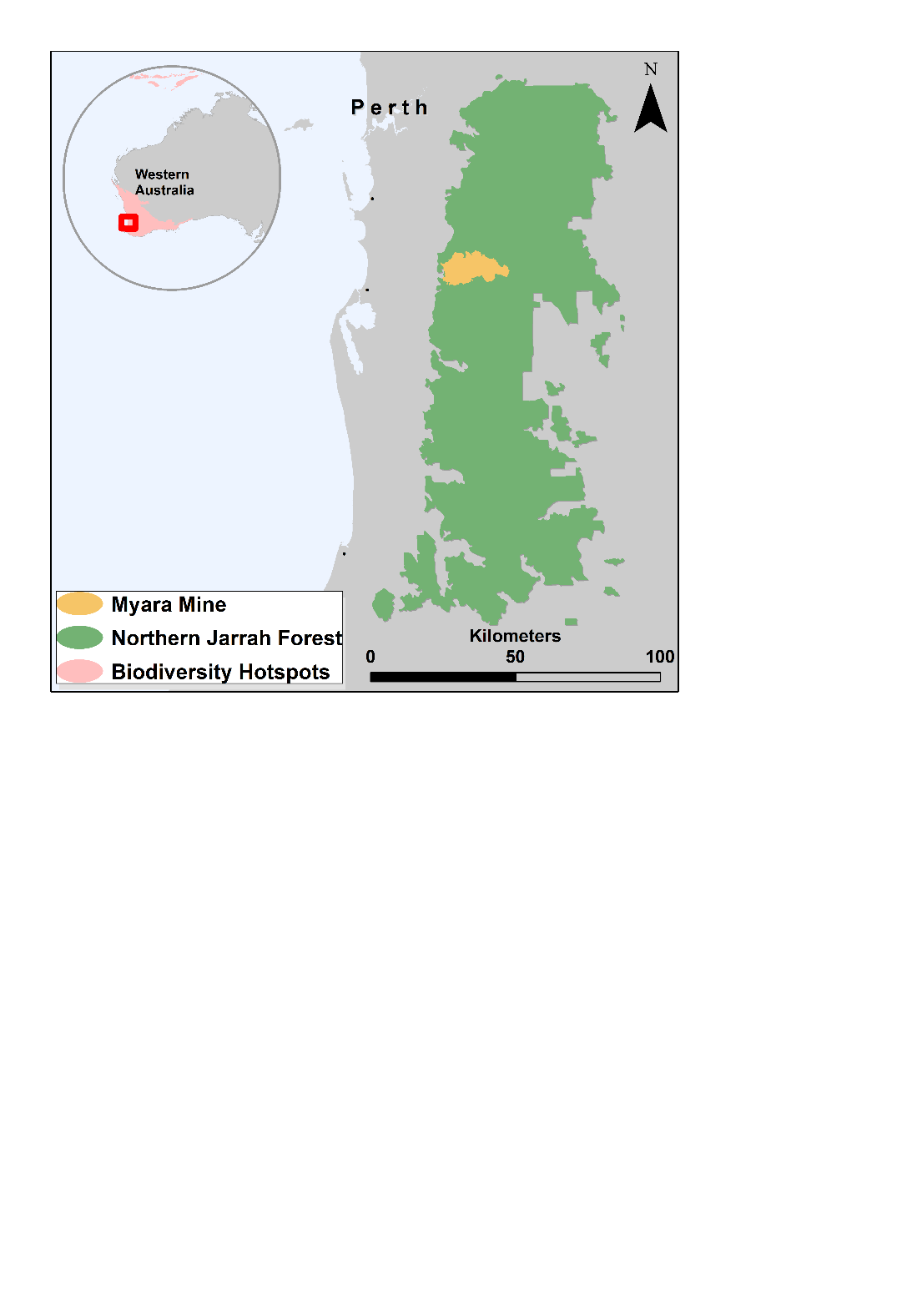

**Fig. 1** Map depicting the geographical extent of the study area for this research. ReZone has been applied to the boundaries of Alcoa’s Myara mine site, which is located within the northern Jarrah forest of south west Western Australia.

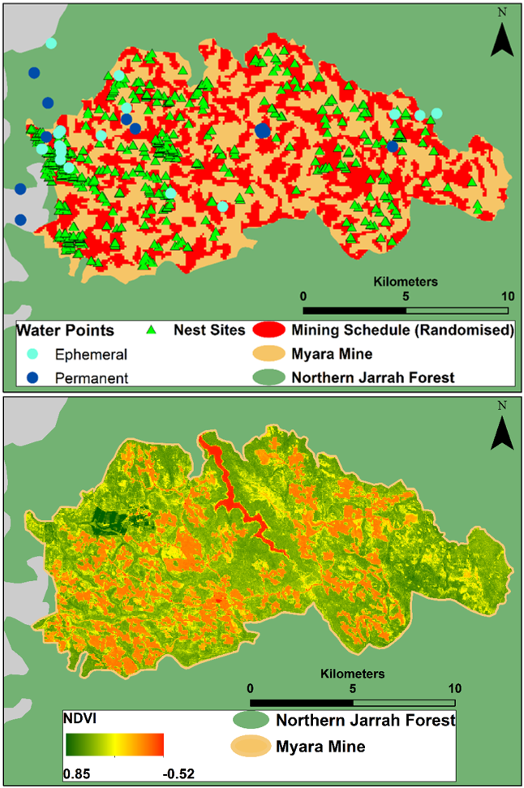

**Fig. 2** The geographic locations and visualisations of the datasets used in this case study. The FRTBC relies on functional resources such as hollow-bearing Eucalyptus trees for nests, water and food from eucalyptus fruit to survive and complete its life-history. We used NDVI derived from Sentinel-2 as a proxy for food resources. The depicted mining schedule has been randomly generated as the actual schedule is proprietary.

**3. Methods**

*Evaluating spatial interactions and landscape value*

To determine regions within the Myara mine lease that would hold functional value for the FRTBC, we evaluated the spatial interactions of the resources they depend on — their nesting sites, water sources and food. Using our comprehensive dataset and user defined parameters or an *R* GUI created using the ‘shiny’ package (Beeley, 2013), users can generate value response functions based on the relevant spatial data and expert opinion to value the spatial relationships of interacting resources (Figure 3).

Suppose that we have an *n×*2 matrix ***X*** that contains *n* two-dimensional locations for the nesting sites with ***Xi.*** = (*xi*1, *xi*2) for *i* = 1, 2, 3,…, *n*. Suppose that we also have an *m*×2 matrix ***Y*** that contains *m* two-dimensional locations for the water points with ***Yi.*** = (*yi*2, *yi*2) for *i* = 1, 2, 3, … , *m*. We then define the distance from each nest point *xi* to the nearest water point as:

|  |  |  |
| --- | --- | --- |
|  |  | (1) |

Once the distance *Mi* for each nest point *xi* is computed, we scale the set of numbers using:

|  |  |  |
| --- | --- | --- |
|  |  | (2) |

Here, *Ni* represents the scaled distance (between 0 and 1) between nest point *xi* and the nearest water point. We then define the response value *Vi* for the first functional resource interaction for each nest point as:

|  |  |  |
| --- | --- | --- |
|  |  | (3) |

Here, *d* is the location of the curve inflection and *a* is the slope of the curve. Both of these parameters are user-defined through data visualisation, and in this case, the parameters were also informed using expert elicitation (Fig. 3). This model represents a response where functional resources (nests) located in close proximity another functional resource (water points) have higher resource interaction values as opposed to resources that are distal. Here, we modelled this response with a sigmoidal function, and the values for interacting resources beyond 2km would become increasingly negligible and eventually map to 0 (Fig.3). Additionally, if a water resource was ephemeral then the value was multiplied by 0.75 to represent how permanent resources would provide more functional value for the FRTBC. For the same nest point we calculate the second resource interaction which is the amount of potential food (NDVI as proxy) available for the FRTBC in a certain radius *Wi.* Let *Ci* be a circle centred at coordinates *xi* = (*xi*1, *xi*1) with radius *D* and let *K* be a set where *k* ∈ *K* if *xk* ∈*Ci*. Then we compute *Wi* with:

|  |  |  |
| --- | --- | --- |
|  |  | (4) |

Here, the radius of distance *D* is set to 1000 m. The final value of the nest point and the result of these functional resources interacting is then:

|  |  |  |
| --- | --- | --- |
|  |  | (5) |

We define the value of the entire landscape as:

|  |  |  |
| --- | --- | --- |
|  |  | (6) |

As each point in the landscape can add value to the nest points, we then evaluate the contribution of every single point in the landscape. To do this we iteratively remove each point and recompute the total landscape value. The value contribution to the total landscape value for a point with coordinates *z* = (*a, b*) is then:

|  |  |  |
| --- | --- | --- |
|  |  | (7) |
|  |  |  |

Where is the landscape value computed with the removal of point *z.* We then apply an exponential decay function with a user defined buffer (500m in this case) at every point of *T* to generate a heat map for the study area (Fig. 5).

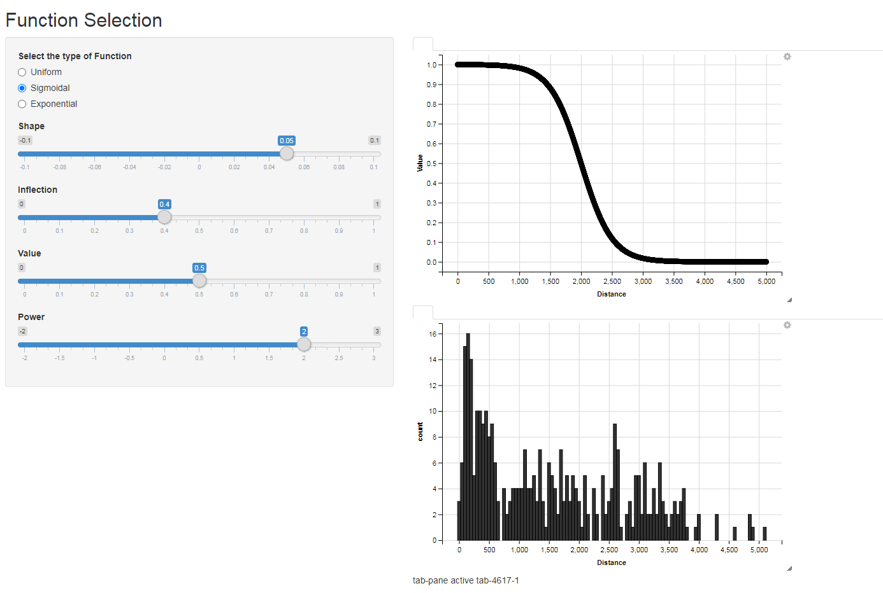

**Fig. 3** The modelled response of spatially interacting resources. Using the Shiny package, we have developed GUIs so that users can specify representative relationships based on data and expert opinion. We provide the user with several functions and parameter choices to complete the modelling procedures. In this case study, the function to model the data is expressed in equation 3.

*A heuristic algorithm to determine biodiversity offset locations*

The configuration and functional connectivity of habitats and resources plays an important role in landscape ecological processes, and this is especially true for the persistence of mobile species (Carvalho et al., 2016; Mastrantonis et al., 2019). In addition, the introduction and management of accessible supplementary resources has been shown to influence the ranges and behaviour of mobile species, while biodiversity offsets can alter land use allocation in conservation prioritisation models (Moilanen et al., 2020; Plummer et al., 2015). With water availability likely playing an important role in the reproductive habitat selection for the FRTBC, including supplementary water points across Alcoa’s mine leases could offset habitat losses due to mining. Determining the optimal location for these supplementary water points is a challenging task, and thus we have developed a heuristic machine learning algorithm that aids in this process. This algorithm places a water point at a random coordinate in the landscape, assesses the set of nearest neighbour landscape points, and the algorithm seeks to maximise equation 6 for the points in this set. The water point then moves to the coordinate that maximises equation 6 and the process continues. If a point does not add value at a coordinate within any given set, the search neighbourhood is expanded. Additionally, if a coordinate in the expanded search neighbourhood set fails to add value to the landscape, the search neighbourhood is expanded a third time. If these three neighbourhood sets fail to maximise equation 6, another random coordinate is generated, and the process repeats until a desired number of water points are placed (see video abstract and simplified pseudo-code below).

nests = ‘nest site location data’

water_points = ‘water point location data’

NDVI = ‘NDVI data’

max_value = landscape_value_function(nests, water_points, NDVI)

iteration= 1

counter = 1

threshold = t

water_points_new = the no. of desired supplementary water points

new_point_list = water_points

while (counter <= water_points_new){

random_point = sample(landscape)

nearest_neighbours = set(random_point)

for (p in nearest_neighbours){

water_matrix = water_points + p

value_i = landscape_value(nests,   
 water_matrix, NDVI)

}

new_point_value = whichmax(value_i)

If (max_value - new_point_value < threshold) {

If (iteration > 3){

break this If section

} else {

nearest_neighbours =  
 next_nearest_neighbours

iteration = iteration + 1

return to line 12

}else{

new_point_list = new_point_list +

new_point_value

max_value =  
 landscape_value(nests,  
 new_point_list ,NDVI)

counter = counter +1

}

}

*The Pareto frontier & land use allocation*

Conservation and economic enterprise often come into conflict, especially in spatial management and multi-objective contexts (Czech, 2008; Faleiro et al., 2013; Nelson et al., 2009), and debate is ongoing on how to conserve nature while maintaining socioeconomic wellbeing (Hobbs et al., 2014). Determining the best trade-offs for both conservation and economic activity is complex and challenging, and in this case we seek to achieve the best trade-offs between these two contrasting objectives using Pareto optimality. As part of this software, we have developed a tool that visualises the Pareto frontier of mining and conservation objectives, and allows the user to select their desired outcomes across the Pareto frontier to generate optimal land use allocations (Fig. 4). This function assesses the overlapping extents of landscape functional value (Fig. 5) and mining (Fig. 2). The user can select the desired amount of mining and assess the trade-offs that that amount of mining will have on landscape functional value. Based on this decision, *ReZone* generates land use designations that seeks to minimise the impact to landscape functional value while meeting the production requirements of the user. Conversely, the user can decide to maximise production while meeting conservation requirements. Using the heuristic algorithm we also simulated (*n* = 10) how the addition of supplementary water points might shift the Pareto frontier and offset mining impacts (Fig. 4). This shift in the Pareto frontier will alter the outcomes of land use allocation for the Myara landscape based on the locations of the biodiversity offsets.

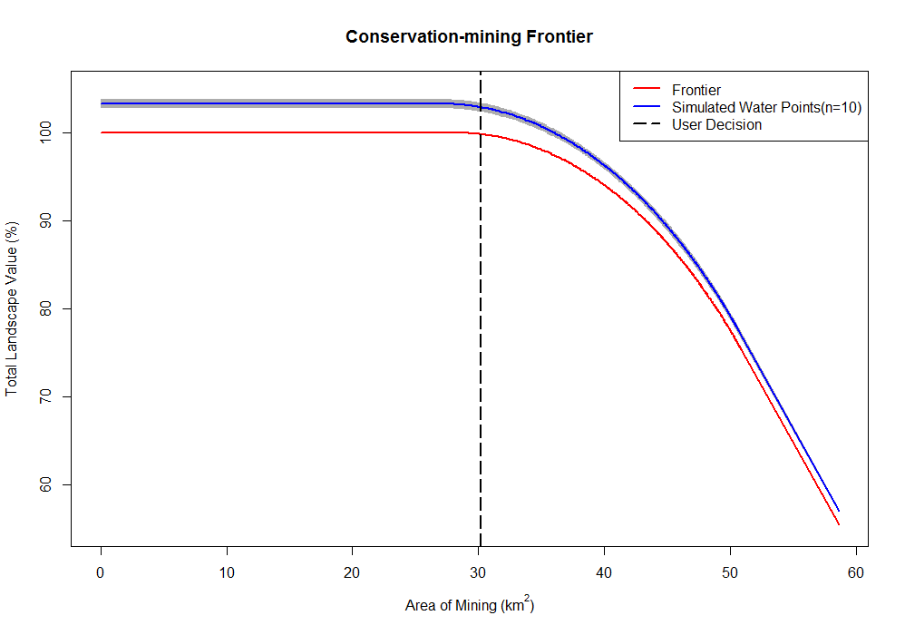

**Fig. 4** We have developed tools to visualise the Pareto frontier between conservation and mining objectives. Users can select any option across the frontier (The red or blue curves) to optimise land use. The hashed line represents the user decision made for this case this case study where negligible impact to landscape functional value will occur.

**4. Model application results and discussion**

The outputs and extents of ecological value, *Tz*,can be observed in Figure 5; where it was estimated that 64.2 km2 land within the Myara mine lease would provide functional resource value for the FRTBC. Much of this value lies on the western edge of the northern Jarrah forest, which experiences relatively higher annual precipitation and trees are generally taller, providing ideal habitat conditions for the FRTBC (Havel, 1989; Mastrantonis et al., 2019). Indeed, a significant number of nesting sites are clustered in the north-westerly region of the Myara mine lease, and these sites are within close proximity to several ephemeral and permanent water points and surrounded by productive vegetation (Fig. 2). For this case study, we decided to mine 30 km2 of the proxy mining schedule (Fig. 4). This extent of mining would scarcely impact the landscape ecological value while potentially allowing Alcoa to extract a significant amount of bauxite from the Myara mine (if this schedule were real). The proposed extents of mining are depicted in Figure 5; where the updated mining schedule will avoid regions that hold ecological value for the FRTBC based on the user-decision made across the Pareto frontier. However, if the decision were made to mine the entire extent of the schedule, we would expect that nearly half of the landscape functional value for the FRTBC would be lost in the process (Fig. 4). With this decision made, *ReZone* will generate explicit land use designations for mining and conservation, and in this case study, we included the areas of rehabilitation and previously cleared land in the output (Fig. 5). It was also observed from our heuristic simulations that adding up to 10 additional supplementary water points would shift the Pareto frontier beyond the current baseline for any extent of mining activity (Fig. 4). This highlights the potential for adding and managing biodiversity offsets across the landscape to aid spatial conservation prioritisation. In fact, Alcoa, in conjunction with regional government agencies, are currently providing permanent water points for the FRTBC to buffer against the impacts of climate change on the population, while future location for water points will be informed using *ReZone*.

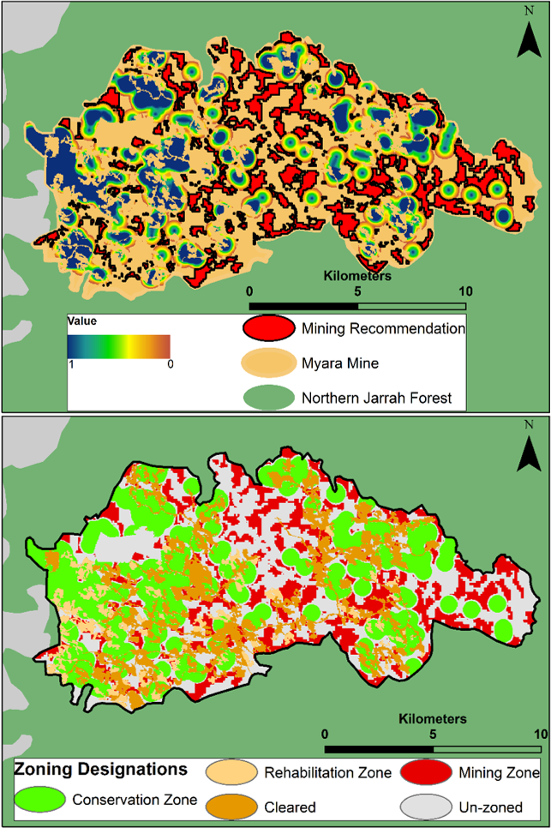

**Fig. 5 Panel A:** The heat map results of evaluating functional resource interactions for the FRTBC across the Myara mine site. **Panel B:** The land use allocation outcomes based on the Pareto frontier for mining and conservation objectives.

**5. Future Prospects**

Here, we have demonstrated the novel use of *ReZone* for multiple-objective decision making and land use allocation in a multiple-use landscape. We have developed an applicable framework for optimisation in conflicted landscapes based explicitly on the spatial interactions of functional resources for a species. We successfully apply functions to generate Pareto optimality between mining and conservation objectives, and generate land use designation with optimal trade-offs between these two contrasting objectives. Moreover, we have developed a heuristic machine learning algorithm that aids in evaluating the optimal location for establishing biodiversity offsets based on the spatial configuration of functional resources. However, the scope for future work and development for *ReZone* is significant. Our focal species is highly mobile and habitat connectivity, or the lack thereof, is unlikely to impact their ability to access and move between resources. On the other hand, ground dwelling or less mobile species are much more likely to be impacted by habitat modification or fragmentation, as their movements patterns and resource acquisition are linked to habitat matrix permeability (Allen and Singh, 2016; Doherty and Driscoll, 2018). Thus, rather than solely modelling ecological value from Euclidean distances between interacting resources, we are now incorporating least-cost pathing or random walk functions from the ‘gdistance’ package (Etten, 2017). This will allow us to assess how an animal’s movement across modified habitats or landscape states may alter the value of functional resources. Moreover, the current version of the model only has functionality to process resources in the form of coordinates or matrices. We aim to expand *ReZone’s* functionality to work with linear features and polygons, while scaling up the possible number of interacting resources that the software can currently process. Importantly, we aim to develop *ReZone* to be able address multi-species scenarios in landscapes with several conflicting stakeholders and socioeconomic values. Finally, we hope to generalise the software so that it may be applied in production landscapes that aren’t necessarily extractive, such as agricultural and even marine environments.

**Software availability**

Name of model: ReZone.  
 Developers: Stanley Mastrantonis.  
 Programming Languages: R.  
 Contact email: stanley.mastrantonis@ research.uwa.edu.au  
 Code and data available at github:

**Declaration of competing interests**

The authors would like to declare that there are no competing interests to declare.

**Acknowledgements**

**References**

Allen, A.M., Singh, N.J., 2016. Linking movement ecology with wildlife management and conservation. Frontiers in Ecology and Evolution 3, 155.

Beeley, C., 2013. Web application development with R using Shiny. Packt Publishing Ltd.

Bull, J.W., Suttle, K.B., Gordon, A., Singh, N.J., Milner-Gulland, E.J., 2013. Biodiversity offsets in theory and practice. Oryx 47, 369–380.

Cameron, M., 2007. Cockatoos. CSIRO publishing, Collingwood, VIC.

Carvalho, F., Carvalho, R., Mira, A., Beja, P., 2016. Assessing landscape functional connectivity in a forest carnivore using path selection functions. Landscape Ecology 31, 1021–1036.

Castrejón, M., Charles, A., 2020. Human and climatic drivers affect spatial fishing patterns in a multiple-use marine protected area: The Galapagos Marine Reserve. PloS one 15, e0228094.

Chapman, T., 2008. Forest Black Cockatoo (Baudin’s Cockatoo Calyptorhynchus baudinii and Forest Red-tailed Black Cockatoo Calyptorhynchus banksii naso) recovery plan. Department of Environment and Conservation.

Czech, B., 2008. Prospects for reconciling the conflict between economic growth and biodiversity conservation with technological progress. Conservation Biology 22, 1389–1398.

Dennis, R.L.H., Shreeve, T.G., Van Dyck, H., 2003. Towards a functional resource-based concept for habitat: a butterfly biology viewpoint. Oikos 417–426.

Di Marco, M., Watson, J.E.M., Possingham, H.P., Venter, O., 2017. Limitations and trade‐offs in the use of species distribution maps for protected area planning. Journal of Applied Ecology 54, 402–411.

Doherty, T.S., Driscoll, D.A., 2018. Coupling movement and landscape ecology for animal conservation in production landscapes. Proceedings of the Royal Society B: Biological Sciences 285, 20172272.

Etten, J. van, 2017. R package gdistance: distances and routes on geographical grids.

Faleiro, F. V, Machado, R.B., Loyola, R.D., 2013. Defining spatial conservation priorities in the face of land-use and climate change. Biological Conservation 158, 248–257.

Grigg, A.H., 2017. Hydrological response to bauxite mining and rehabilitation in the jarrah forest in south west Australia. Journal of Hydrology: Regional Studies 12, 150–164.

Grigg, A.H., Steele, A.J., 2011. The longevity of constructed log pile fauna habitats in restored bauxite mines in relation to recurrent wildfire in the jarrah forest of Western Australia. Ecological Management & Restoration 12, 138–140.

Havel, J.J., 1989. Conservation in the northern jarrah forest. The jarrah forest: a complex Mediterranean ecosystem 379–399.

Hawkins, B.A., Diniz‐Filho, J.A.F., Soeller, S.A., 2005. Water links the historical and contemporary components of the Australian bird diversity gradient. Journal of Biogeography 32, 1035–1042.

Hobbs, R.J., Higgs, E., Hall, C.M., Bridgewater, P., Chapin III, F.S., Ellis, E.C., Ewel, J.J., Hallett, L.M., Harris, J., Hulvey, K.B., 2014. Managing the whole landscape: historical, hybrid, and novel ecosystems. Frontiers in Ecology and the Environment 12, 557–564.

Huang, I.B., Keisler, J., Linkov, I., 2011. Multi-criteria decision analysis in environmental sciences: Ten years of applications and trends. Science of the total environment 409, 3578–3594.

Jetz, W., McGeoch, M.A., Guralnick, R., Ferrier, S., Beck, J., Costello, M.J., Fernandez, M., Geller, G.N., Keil, P., Merow, C., 2019. Essential biodiversity variables for mapping and monitoring species populations. Nature Ecology & Evolution 3, 539–551.

Johnstone, R.E., Kirkby, T., Sarti, K., 2013a. The breeding biology of the Forest Red-tailed Black Cockatoo Calyptorhynchus banksii naso Gould in south-western Australia. II. Breeding behaviour and diet. Pacific Conservation Biology 19, 143–155.

Johnstone, R.E., Kirkby, T., Sarti, K., 2013b. The breeding biology of the forest red-tailed black cockatoo Calyptorhynchus banksii naso Gould in south-western Australia. I. Characteristics of nest trees and nest hollows. Pacific Conservation Biology 19, 121–142.

Jones, K.R., Watson, J.E.M., Possingham, H.P., Klein, C.J., 2016. Incorporating climate change into spatial conservation prioritisation: A review. Biological Conservation 194, 121–130.

Jumin, R., Binson, A., McGowan, J., Magupin, S., Beger, M., Brown, C.J., Possingham, H.P., Klein, C., 2018. From Marxan to management: ocean zoning with stakeholders for Tun Mustapha Park in Sabah, Malaysia. Oryx 52, 775–786.

Kaim, A., Cord, A.F., Volk, M., 2018. A review of multi-criteria optimization techniques for agricultural land use allocation. Environmental Modelling & Software 105, 79–93.

Kennedy, M.C., Ford, E.D., Singleton, P., Finney, M., Agee, J.K., 2008. Informed multi‐objective decision‐making in environmental management using Pareto optimality. Journal of Applied Ecology 45, 181–192.

Koch, J.M., 2007. Alcoa’s mining and restoration process in south Western Australia. Restoration Ecology 15, S11–S16.

Koch, J.M., Hobbs, R.J., 2007. Synthesis: is Alcoa successfully restoring a jarrah forest ecosystem after bauxite mining in Western Australia? Restoration ecology 15, S137–S144.

Lotov, A. V, Miettinen, K., 2008. Visualizing the Pareto frontier, in: Multiobjective Optimization. Springer, pp. 213–243.

Macfarlane, C., Grigg, A.H., Daws, M.I., 2017. A standardised Landsat time series (1973–2016) of forest leaf area index using pseudoinvariant features and spectral vegetation index isolines and a catchment hydrology application. Remote Sensing Applications: Society and Environment 6, 1–14.

Mastrantonis, S., Craig, M.D., Renton, M., Kirkby, T., Hobbs, R.J., 2019. Climate change indirectly reduces breeding frequency of a mobile species through changes in food availability. Ecosphere 10, e02656.

Moilanen, A., Franco, A.M.A., Early, R.I., Fox, R., Wintle, B., Thomas, C.D., 2005. Prioritizing multiple-use landscapes for conservation: methods for large multi-species planning problems. Proceedings of the Royal Society of London B: Biological Sciences 272, 1885–1891.

Moilanen, A., Kujala, H., Mikkonen, N., 2020. A practical method for evaluating spatial biodiversity offset scenarios based on spatial conservation prioritization outputs. Methods in Ecology and Evolution.

Myers, N., Mittermeier, R.A., Mittermeier, C.G., Da Fonseca, G.A.B., Kent, J., 2000. Biodiversity hotspots for conservation priorities. Nature 403, 853–858.

Nelson, E., Mendoza, G., Regetz, J., Polasky, S., Tallis, H., Cameron, Dr., Chan, K., Daily, G.C., Goldstein, J., Kareiva, P.M., 2009. Modeling multiple ecosystem services, biodiversity conservation, commodity production, and tradeoffs at landscape scales. Frontiers in Ecology and the Environment 7, 4–11.

Nicholson, E., Westphal, M.I., Frank, K., Rochester, W.A., Pressey, R.L., Lindenmayer, D.B., Possingham, H.P., 2006. A new method for conservation planning for the persistence of multiple species. Ecology letters 9, 1049–1060.

Plummer, K.E., Siriwardena, G.M., Conway, G.J., Risely, K., Toms, M.P., 2015. Is supplementary feeding in gardens a driver of evolutionary change in a migratory bird species? Global change biology 21, 4353–4363.

Shen, X., Li, S., McShea, W.J., Wang, D., Yu, J., Shi, X., Dong, W., Mi, X., Ma, K., 2020. Effectiveness of management zoning designed for flagship species in protecting sympatric species. Conservation Biology 34, 158–167.

Studds, C.E., Marra, P.P., 2011. Rainfall-induced changes in food availability modify the spring departure programme of a migratory bird. Proceedings of the Royal Society of London B: Biological Sciences rspb20110332.

Studwell, A.J., Hines, E., Elliott, M.L., Howar, J., Holzman, B., Nur, N., Jahncke, J., 2017. Modeling nonresident seabird foraging distributions to inform ocean zoning in Central California. PloS one 12.

Venegas‐Li, R., Levin, N., Possingham, H., Kark, S., 2018. 3D spatial conservation prioritisation: Accounting for depth in marine environments. Methods in Ecology and Evolution 9, 773–784.

Watts, M.E., Ball, I.R., Stewart, R.S., Klein, C.J., Wilson, K., Steinback, C., Lourival, R., Kircher, L., Possingham, H.P., 2009. Marxan with Zones: software for optimal conservation based land-and sea-use zoning. Environmental Modelling & Software 24, 1513–1521.

Xevi, E., Khan, S., 2005. A multi-objective optimisation approach to water management. Journal of environmental management 77, 269–277.

Xi, B.D., Su, J., Huang, G.H., Qin, X.-S., Jiang, Y.H., Huo, S.L., Ji, D.F., Yao, B., 2010. An integrated optimization approach and multi-criteria decision analysis for supporting the waste-management system of the City of Beijing, China. Engineering Applications of Artificial Intelligence 23, 620–631.